**HDFC NEW UPI LAUNCH**

**Business Requirements Document (BRD)**

**1.Document Revision:**

|  |  |  |
| --- | --- | --- |
| **Date** | **Version Number** | **Document Changes** |
| 18/11/2024 | 0.1 | Draft Initial version of BRD for PROJECT ID 13494 |
| 19/11/2024 | 0.2 | Changes done in Introduction details (3.1.1) |
| 19/11/2023 | 1.0 | Final version of BRD |
|  |  |  |
|  |  |  |
|  |  |  |
|  |  |  |
|  |  |  |
|  |  |  |

**2.Approvals**

|  |  |  |  |  |
| --- | --- | --- | --- | --- |
| **Role** | **Name** | **Title** | **Approval** | **Date** |
| Project Sponsor | NARESH |  | Approved | 18-12 |
| Business Owner | JEEVA |  | PENDING | 19-12 |
| Project Manager | Karthi |  | NA | xx |
| System Architect | Suresh |  | Approved | 19-12 |
| Development Lead | Deepa |  | Approved | 20-12 |
| User Experience Lead | Ram |  | PENDING | 21-12 |
| Business Analyst | Prakash, Deepak |  | PENDING | 21-12 |
| Content Lead | Santhosh |  | NA | xx |

**3.Introduction**

3.1 Project summary

3.1.1 Objectives

[*The creation or enhancement of a UPI system requires clear and actionable objectives focused on improving* ***user experience****, ensuring* ***security****, promoting* ***adoption****, and expanding the system’s capabilities to meet the needs of all stakeholders. global payments landscape.*]

🡪focused on improving user experience

🡪UPI can continue to be a transformative tool

🡪paving the way for greater financial inclusion, efficiency

3.1.2 Background

*[The need for a new or enhanced UPI system arises from the rapid growth of the digital economy,]*

There is still room to improve the user experience. New features could include voice-enabled payments, biometric authentication.

3.1.2.1 Business Drivers

[*business drivers that align with the broader goals of improving customer experience, enhancing revenue, expanding market reach,]*

* Enhanced **user satisfaction**.
* Increased **customer engagement** and **loyalty**.

Reduced churn as UPI enhances accessibility for both urban and rural customers.

3.2 Project Scope

*[The scope of this project is to develop, enhance, and expand HDFC Bank’s UPI capabilities to deliver superior customer experience, promote digital adoption, and create new revenue streams. It includes the development of new features, increased merchant adoption, and enhanced.]*

**3.2.1 In Scope Functionality**

🡪User Registration & Onboarding

🡪VPA (Virtual Payment Address)

🡪Multi-device Support

🡪Loan Repayments & Financial Services

**3.2.2 Out Scope Functionality**

🡪 Integration with Non-Indian Payment Systems

🡪 Cross-Platform and Cross-Network Interoperability

🡪 New Payment Channels and Technologies

**3.3 System perspective**

*[system perspective defines how the UPI platform fits within the larger technology architecture of HDFC Bank. It outlines the relationship between the various components of the system]*

**3.3.1 User Devices**

The mobile app (HDFC Bank’s proprietary UPI app or integrated banking app) will be the primary interface through which users initiate UPI transactions. The app will be available on Android and iOS devices, ensuring compatibility with the majority of smartphones.

* + 1. **Constraints**
* **Transaction limits (e.g., maximum daily transaction limit).**
* **Security standards (e.g., multi-factor authentication, encryption protocols).**

**🡪Data privacy laws (e.g., storing and processing of user data as per India’s data protection guidelines).**

**3,3.3 Risk**

**Risk**: Unexpected downtime or service outages in HDFC Bank’s UPI platform could disrupt payment processing, affecting users and merchants.

**Impact**: A major outage could cause loss of trust, financial transactions could fail, and customer satisfaction would drop significantly

**4.Wireframe Design**

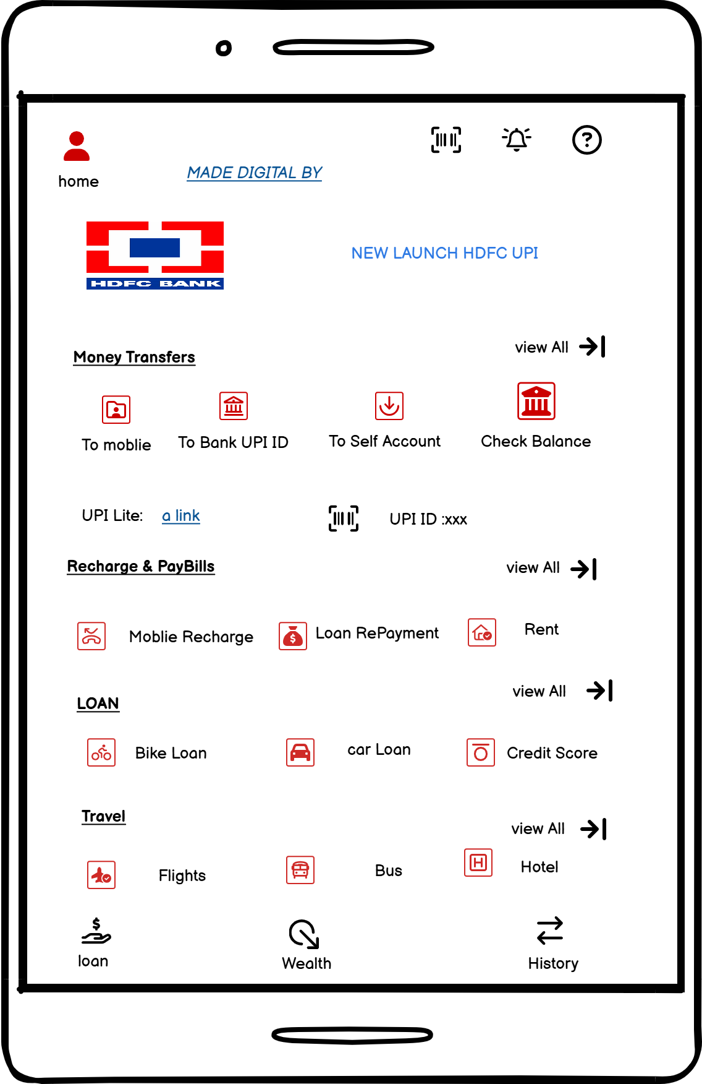

*[A wireframe for a website or app interface that deals with HDHP and UPI]*

🡪**The wireframe would usually be a basic layout representing the design and structure of a webpage or app screen. Let me know more details so I can assist you in creating a design concept!**

**5.Business Process Overview**

*[high-level summary of the processes that an organization uses to achieve its objectives. It typically includes descriptions of key workflows, systems, stakeholders, and their interactions. The goal is to provide a clear understanding of how various activities, resources, and technologies work together to deliver value and meet business goals.]*

**5.1 Current Business Process view**

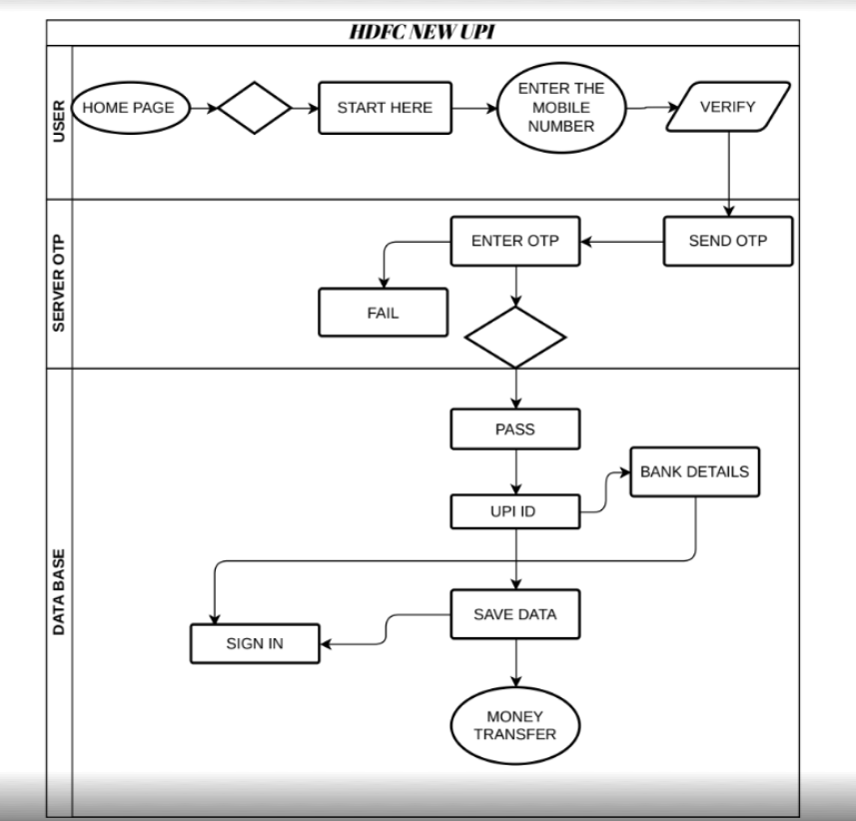

**6.Business Requirement**

*[system that integrates* ***HDFC UPI (Unified Payments Interface)*** *can be essential for developing or enhancing the platform for seamless transactions. The document would include the key business objectives, stakeholders, technical requirements]*

The requirements in this document are prioritized as follows:

|  |  |  |
| --- | --- | --- |
| **Value** | **Rating** | **Description** |
| 1 | Critical | The requirement typically indicates that it is essential for the success of the business or the project's objectives |
| 2 | High | A "High" business requirement rating signifies a task or feature that plays a significant role in the business's success |
| 3 | Medium | The impact on business operations, customer satisfaction, or revenue is relatively moderate compared to critical or high-priority requirements. |
| 4 | Low | This is a low priority requirement, or a “nice to have” feature, if time and cost allow it. |
| 5 | Future | As the UPI 2.0 and subsequent versions evolve, HDFC Bank will likely have to adopt and integrate new features |

**5.1 Business Requirement:**

**BR-001 _User Registration Module:**

1.Create new User registration screen on the new website **(**[**https://www.hdfcupi.com**](https://www.hdfcupi.com)**)**

2.The screen should be user friendly and the registration should be completed **HDFC User only.**

3.This Functional Activated Only HDFC Bank Holder.

4.Bank register mobile number or account number should be completed for successful registration. Validation should be done in OTP level.

5. For successfully registered and validated.

**BR-002 New UPI payments Features:**

1.All kinds of States should be accepted.

2.Rewards Points

3 Most Safest UPI Payment.

**5.2 Functional Requirement:**

**HDFC UPI App Interface**

*[Screenshots: Visual aids to help users better understand how to navigate the app. These might include screens for]*

* ***Signing in***
* ***Linking a bank account***
* ***Making payments***
* ***Settings and security options***

***5.3 Non -Functional Requirement***

*[Non-functional requirements (NFRs) for a product like the new HDFC UPI app are essential for ensuring the app performs]*

|  |  |
| --- | --- |
| **ID** | **Requirement** |
| NFR-001 | Performance |
| NFR-002 | Transaction Speed |
| NFR-003 | Availability |
| NFR-004 | Security |
| NFR-005 | Usability |

**6.Appendices**

**6.1 Features**

*[Key functionalities of the app, such as quick money transfers, bill payments, scan & pay, and the ability to link multiple bank accounts.]*

***6.2* *Technology***

*[ The underlying technology powering the UPI feature in the app, including security]*

***Common Issues:***

*[Solutions to issues like transaction failure, UPI PIN reset, app crashes, or account linking problems.]*